**Introduction to internet and web browsing**

**Introduction**

It's no secret that more and more the internet is becoming an integral part of our everyday lives. But if you are new to the online experience, it may be a bit overwhelming. You may be wondering, **"What exactly is the internet, and how does it work?"**

In this lesson, we will give a **brief overview** of the internet, and we will talk about some fundamental concepts such as **networks, servers**, and **clients.**

**The Internet Today**

In the early days, most people just used the internet to search for information. Today's internet is a constantly evolving tool, that not only contains an amazing variety of information, but also provides new ways of accessing, interacting and connecting with people and content. As a result, new terms are constantly appearing as new technologies are introduced.

**What is the Internet?**

The internet is the largest **computer network** in the world, connecting millions of computers. A **network** is a group of two or more computer systems linked together.

**Servers and Clients**

You may have heard someone say something like "The server is down" or "We're having problems with the e-mail server."

A **server** is a computer that "serves" many different computers in a network by **running specialized software** and **storing** **information**. For example, web pages are stored on servers. When you access a web page, your computer is acting as a **client**. A client runs familiar software such as **web browsers** or **email software**, and it communicates with the server to get the information it requires.

In order for your browser to display a web page, it **requests** the data from the server where the page is stored. The server processes the request, and then sends the data to your browser, where it is displayed.

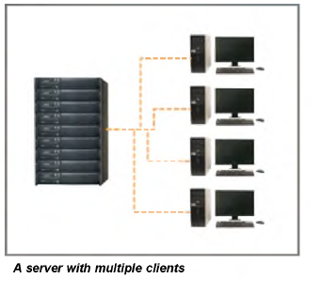

**The World Wide Web (WWW)**

When most people think of the internet, the first thing they think about is the **World Wide Web**. Nowadays, the terms "internet" and "World Wide Web" are often used interchangeably—but they're actually not the same thing.

* The **internet** is the **physical network** of computers all over the world.
* The **World Wide Web** is a **virtual network** of **web sites** connected by **hyperlinks** (or **"links"**). Web sites are stored on **servers** on the internet, so the World Wide Web is a part of the internet.

**HTML**

The backbone of the World Wide Web is made of **HTML files**, which are specially-formatted documents that can contain links, as well as images and other media. All **web browsers** can read HTML files. In addition to HTML, it's also very common for websites to use technologies like **CSS (Cascading Style Sheets)** and **JavaScript** to do more advanced things.

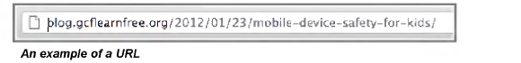

The World Wide Web was created in 1989 by **Tim Berners-Lee**, a software engineer. Before then, computers could communicate over the internet, but there were no web pages.

**How is internet used**

There's almost no limit to what you can do online. The Internet makes it possible to quickly find information, communicate with people around the world, manage your finances, shop from home, listen to music, watch videos, and much, much more. Let's take a look at some of the ways the Internet is most commonly used today.

**Finding information online**

With billions of websites online today, there is **a lot**of information on the Internet. **Search engines**make this information easier to find. All you have to do is type one or more**keywords**, and the search engine will look for **relevant websites**.

**Email**

Short for electronic mail, **email** is a way to **send and receive messages** across the Internet. Almost everyone who uses the Internet has their own email account, usually called an **email address**. This is because you'll need an email address to do just about anything online, from online banking to creating a Facebook account.

**Social networking**

**Social networking websites** are another way to**connect and share** with your family and friends online. Rather than sharing with just a few people over email, social networks make it easier to **connect** and **share** with many people at the same time. [**Facebook**](http://www.facebook.com/) is the world's largest social networking site, with **more than** **1 billion users**worldwide.

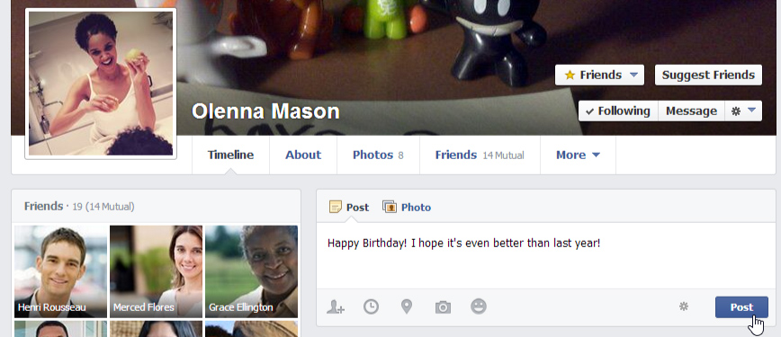

Chat and instant messaging

**Chat** and **instant messaging (IM)**are short messages sent and read **in real time**, allowing you to converse more quickly and easily than email. These are generally used when both (or all) people are online, so your message can be read immediately. By comparison, **emails** won't be seen until recipients check their inboxes.

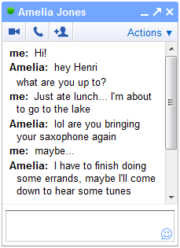

Examples of instant messaging applications include **Yahoo Messenger** and **Google Hangouts**. Some sites, like **Gmail** and **Facebook**, even allow you to chat within your web browser.

**Online media**

There are many sites that allow you to **watch videos**and **listen to music**. For example, you can watch millions of videos on [**YouTube**](https://www.youtube.com/) or listen to Internet radio on [**Pandora**](http://www.pandora.com/).

Other services, like [**Netflix**](http://www.netflix.com/) and **[Hulu](http://www.hulu.com/" \t "_blank)**, allow you to watch movies and TV shows. And if have a **set-top streaming box**, you can even watch them directly on your television instead of a computer screen.

**Everyday tasks**

You can also use the Internet to complete many **everyday tasks** and **errands**. For example, you can manage your bank account, pay your bills, and shop for just about anything. The main advantage here is **convenience**. Rather than going from place to place, you can do all of these tasks at home!

**How do I connect to the Internet?**

Once you've set up your computer, you may want to purchase **home** **Internet access** so you can send and receive email, browse the Web, stream videos, and more. You may even want to set up a **home wireless network**, commonly known as **Wi-Fi**, so you can connect multiple devices to the Internet at the same time.

**Using a web browser**

A web browser is a type of software that allows you to find and view websites on the Internet. There are many different web browsers, but some of the most common ones include Google Chrome, Internet Explorer, Safari, and Mozilla Firefox.

**Browsing with Firefox**

Firefox makes browsing the web quick and easy. In this lesson, we'll talk about **navigating** **to websites** in Firefox. You'll also learn how use **tabs**, access your **browsing history**, and view your **downloads**

**To navigate to a website:**

1. Enter a **web address**—also known as a **URL**—into the address bar, then press **Enter**.

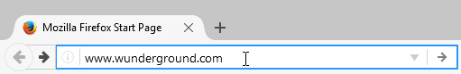

1. The website will appear.

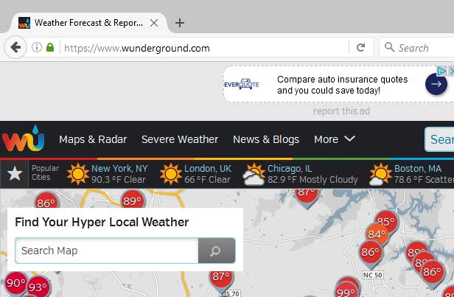

**To search the web:**

Firefox makes it easy to **search the Web** for the information you need. Rather than navigating to a search engine like Google or Bing, you can perform a Web search directly from the **search box**.

1. In the **search box** to the right of the address bar, type a search term, then press **Enter** or click the **Search** icon.

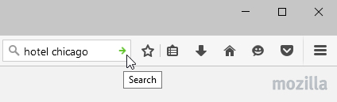

1. The search results will appear.

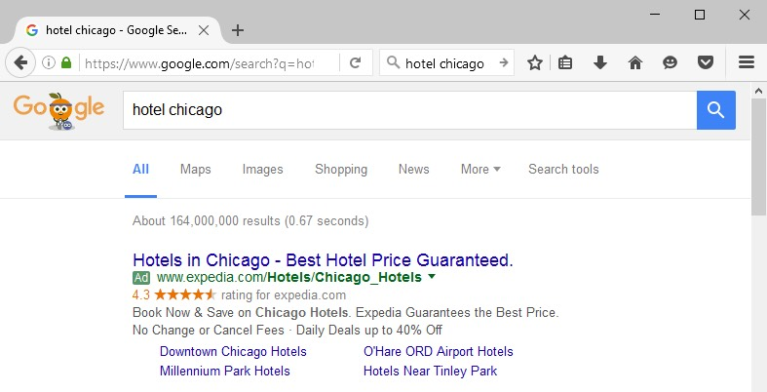

You can click the**magnifying glass icon** to select a different search engine, or click **Change Search Settings** to add or remove search engines.

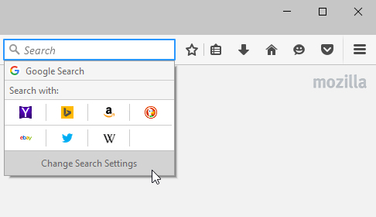

**Navigating in Firefox**

Firefox uses four main buttons for navigation: the Back, Forward, Refresh, and Home buttons.

* The Back button allows you to move back through pages you have recently viewed. Click and hold the Back button to see your recent history.

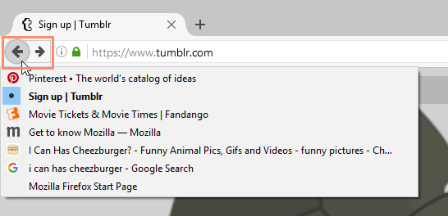

* When you click the **Back** button, the **Forward**button will appear next to it. You can use it to navigate forward in your recent history.

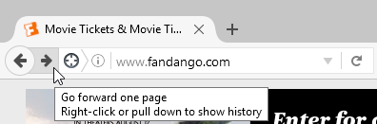

* The **Refresh** button will **reload**the current page. If a website stops working, try using the Refresh button. When a website is loading, the Refresh button will temporarily become the **Stop**button, which you can click to stop a webpage from loading.

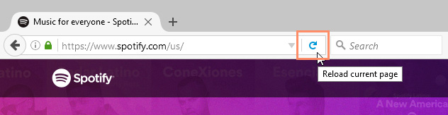

* Clicking the **Home** button will take you directly to your homepage.

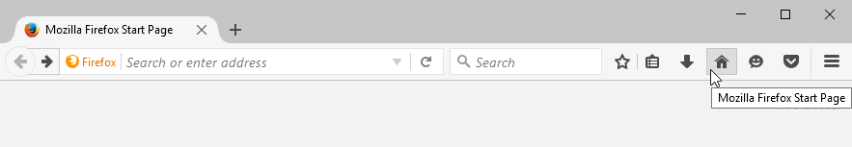

By default, the Home button will navigate to the **Firefox start page.**

**Windows and tabs**

Like all browsers, Firefox allows you to open new windows to view different pages. Firefox also allows you to open multiple websites in the same window using **tabs**. Tabs are usually more convenient than opening several windows at the same time.

**To open a new window:**

* Click the **menu** **button** in the top-right corner of the browser, then select **New Window**. Alternatively, press **Ctrl+N** on your keyboard.

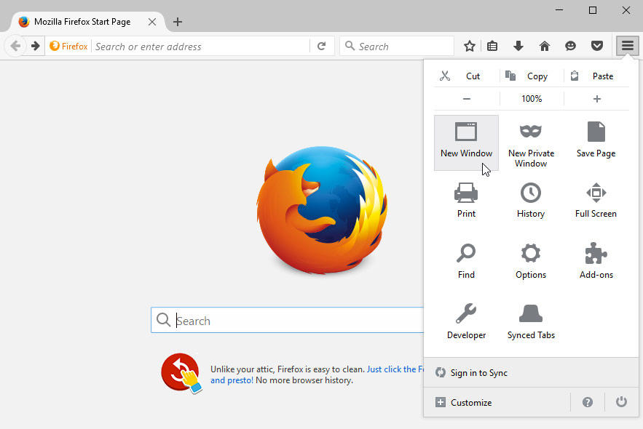

* The new window will appear.

**To open a new tab:**

* Click the plus sign (+) to the right of the open tab. Alternatively, press Ctrl+T on your keyboard.

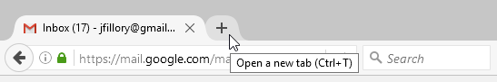

* The**new tab** will appear. Type an address and press **Enter** to navigate to a new page.

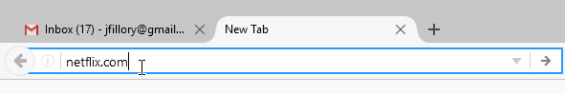

* The website will appear in the new tab.

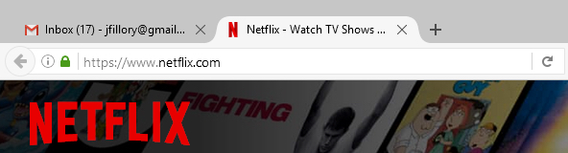

Whenever you open a new tab, the **New Tab**page will appear. The New Tab page will show thumbnails of the websites you visit most frequently. You can click any thumbnail to navigate to that page.

**To close a tab:**

* To **close** a tab, hover the mouse over any tab and click the **Close tab** button. Alternatively, you can press **Ctrl+W** on your keyboard to close the current tab.

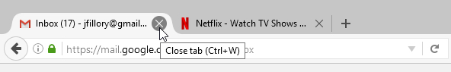

**Browsing history**

Like all browsers, Firefox keeps a record of the websites you visit, which is known as your browsing history. Firefox allows you to search your history to find a previously viewed page and delete your history for the sake of privacy.

**To view your browsing history:**

* Click the menu button in the top-right corner of the browser, select History, then select Show All History.

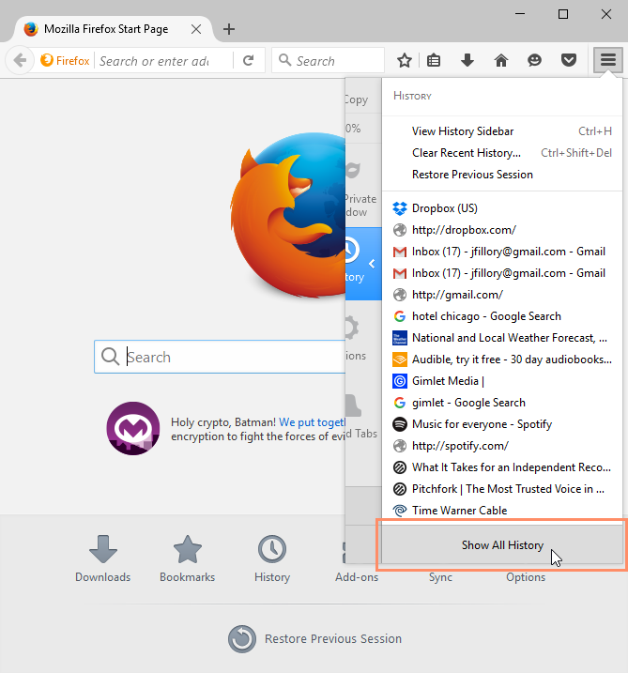

* The **Library** will appear in a new window with your **recent browsing history**. The history includes every site you've viewed in the last week. The list is sorted by date, so the most recent history appears at the top of the page. If you want to return to a website, simply double-click the link.

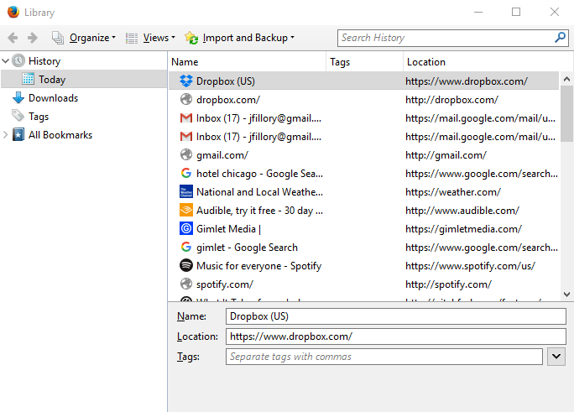

* If you can't remember the exact address or name of a webpage you've visited before, you can try searching the history. Enter a search term or website into the search bar. A list of results will appear automatically.

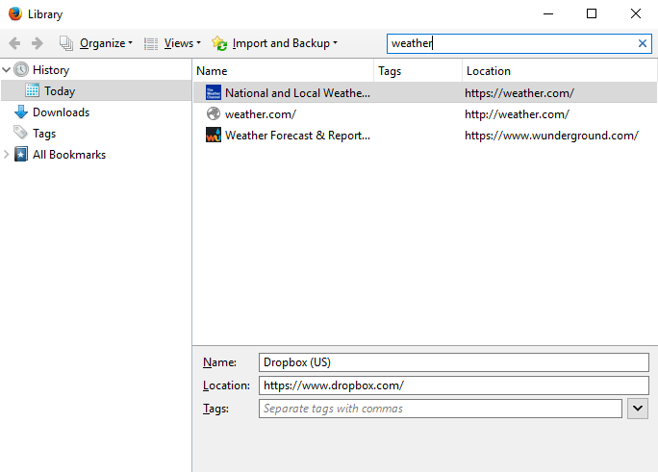

**Downloading files**

Firefox can display many different types of documents, media, and other files, including PDF and MP3 files. But there may be times when you'll want to access a file outside of the browser. To do this, you'll need to **download** **the file** directly to your computer.

For example, let's say you need to complete and print a form you find online. You could download it to your computer, then open it with the appropriate program (such as **Microsoft Word**) to edit it.

* Right-click the file you want to download, then select **Save Link As**...

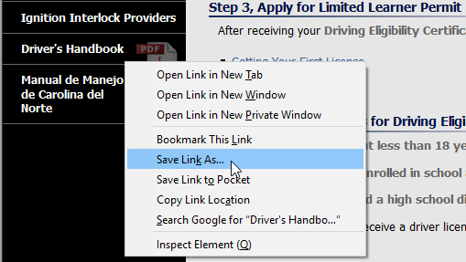

* A dialog box will appear. Select the **location** where you want to save the file, enter a **file name**, and click **Save**. Your **Downloads** folder will be selected by default.

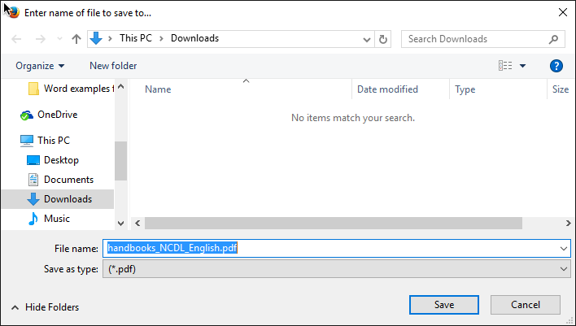

* The file will begin downloading, and the**download progress** will appear in the top-right corner of the browser under the **Downloads** button. When the download is complete, click the file to open it.

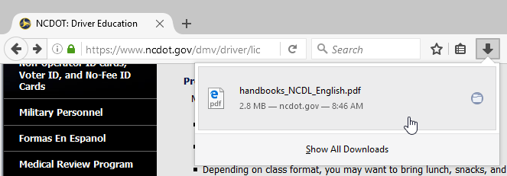

For various reasons, many websites do not allow you to download content. For example, YouTube does not offer a way to download its videos.

**To access your downloads:**

Firefox makes it easy to view and manage all of your downloads.

* Click the **Downloads** button, and then select **Show All** **Downloads**.

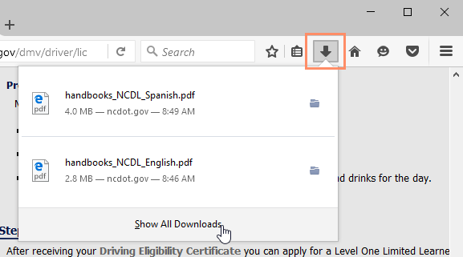

* The **Library** will appear in a new window with a list of all of your downloaded files. From here, you can open previously downloaded files; search for downloads, and clear your list of downloads.